WEEK 2-TDD USING JUNIT5 AND MOCKITO

EXERCISE 1: SETTING UP JUNIT
Scenario:
You need to set up JUnit in your Java project to start writing unit tests.
Steps:
- Create a new Java project in your IDE (VS Code, Eclipse, or IntelliJ IDEA).
- Add the JUnit dependency to the project.
- Create a Java class to be tested.
- Create a test class using JUnit.
- Run the test case and verify the output.

JUnit Dependency (pom.xml):
<dependency>
<groupId>junit</groupId>
<artifactId>junit</artifactId>
<version>4.13.2</version>
<scope>test</scope>
</dependency>

CODE:
Calculator.java
package com.example;
public class Calculator {
public int add(int a, int b) {
return a + b;
}
}
CalculatorTest.java
package com.example;
import org.junit.Test;
import static org.junit.Assert.assertEquals;
public class CalculatorTest {
@Test
public void testAdd(){
Calculator calc = new Calculator();
//checks whether the actual result is equal to the expected result.
assertEquals(7, calc.add(3, 4));
}
}
OUTPUT:
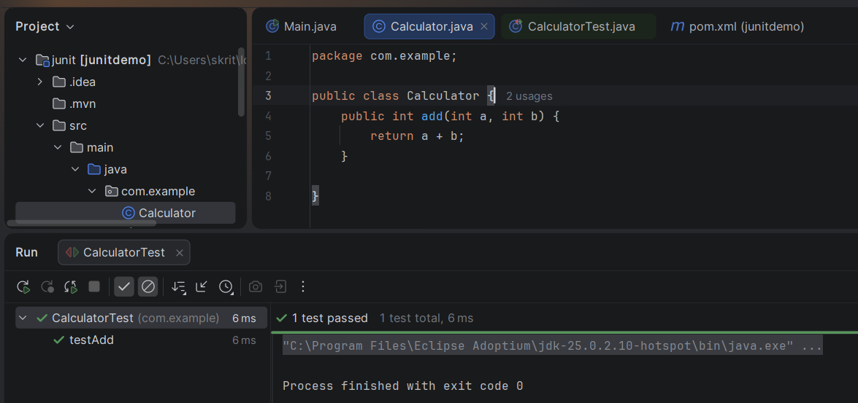

EXERCISE 3: ASSERTIONS IN JUNIT
Scenario:
You need to use different assertions in JUnit to validate your test results.
Steps:
- Create a test class named AssertionsTest.
- Import JUnit assertions.
- Write test cases using different assertion methods such as assertEquals(), assertTrue(), assertFalse(), assertNull(), and assertNotNull().
Execute the test using Maven or your IDE.

Solution Code:
package com.example;
import org.junit.Test;
import static org.junit.Assert.*;
public class AssertionsTest {
@Test
public void testAssertions() {
assertEquals(5, 2 + 3);
assertTrue(5 > 3);
assertFalse(5 < 3);
assertNull(null);
assertNotNull(new Object());
}
}
OUTPUT:
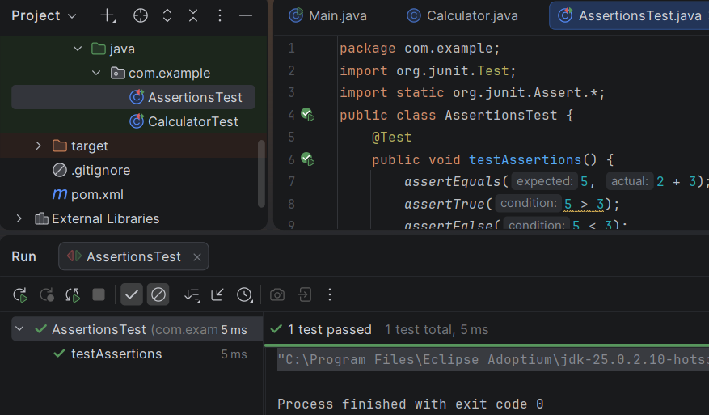

Exercise 4: Arrange-Act-Assert (AAA) Pattern, Test Fixtures, Setup and Teardown Methods in JUnit
Scenario - You need to organize your tests using the Arrange-Act-Assert (AAA) pattern and use setup and teardown methods.
Steps:
- Create a BankAccount class with basic operations:
  - deposit()
  - withdraw()
- Create a JUnit test class.
- Use @Before method to initialize the account before every test.
- Use @After method to clean up after every test.
- Write test cases using AAA pattern:
  - Arrange → prepare input
  - Act → call method
  - Assert → verify result

CODE:
BankAccount.java
package com.example;
public class BankAccount{
private int balance = 0;
public void deposit(int amount){
balance += amount;
}
public void withdraw(int amount){
balance -= amount;
}
public int getBalance() {
return balance;
}
}

BankAccountTest.java (JUnit Test)
package com.example;
import org.junit.Before;
import org.junit.After;
import org.junit.Test;
import static org.junit.Assert.*;
public class BankAccountTest{
BankAccount account;
@Before
public void setUp(){
account = new BankAccount();
System.out.println("Setup: Account created");
}
@After
public void tearDown(){
account = null;
System.out.println("Teardown: Account cleared");
}
@Test
public void testDeposit(){
int amount = 500;
account.deposit(amount);
assertEquals(500, account.getBalance());
}
@Test
public void testWithdraw(){
account.deposit(1000);
int withdrawAmount = 300;
account.withdraw(withdrawAmount);
assertEquals(700, account.getBalance());
}
}

OUTPUT:
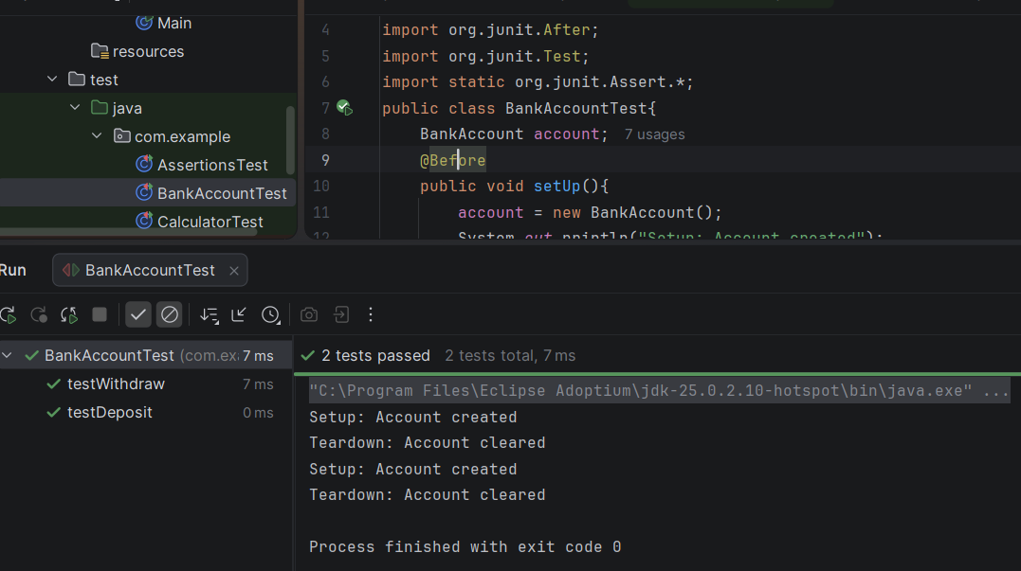

MOCKITO HANDS-ON EXERCISES

EXERCISE 1: Mocking and Stubbing
Scenario: You need to test a service that depends on an external API. Use Mockito to mock the external API and stub its methods.

Steps:
1. Create a mock object for the external API.
2. Stub the method to return a predefined value.
3. Inject the mock object into the service class.
4. Call the service method.
5. Verify the returned result using assertion.

CODE:
package com.example;
import org.junit.Test;
import static org.junit.Assert.assertEquals;
import static org.mockito.Mockito.*;
public class MyServiceTest {
@Test
public void testExternalApi() {
// Create a mock object
ExternalApi mockApi = mock(ExternalApi.class);
// Define the mock behavior
when(mockApi.getData()).thenReturn("Mock Data");
// Pass the mock to MyService
MyService service = new MyService(mockApi);
// Call the method
String result = service.fetchData();
// Verify the result
assertEquals("Mock Data", result);
}
}

package com.example;
public class MyService {
private ExternalApi externalApi;
public MyService(ExternalApi externalApi) {
this.externalApi = externalApi;
}
public String fetchData() {
return externalApi.getData();
}
}
package com.example;
public interface ExternalApi {
String getData();
}

OUTPUT:
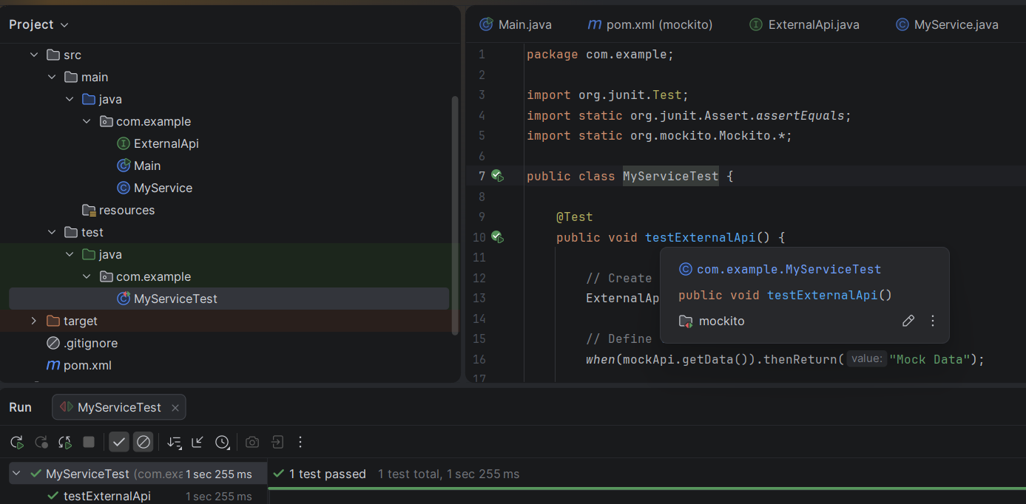

EXERCISE 2: Verifying interactions

Scenario: You need to ensure that a method is called with specific arguments.
Steps:
1. Create a mock object of the external API.
2. Inject the mock into the service class.
3. Call the service method.
4. Verify that the external API method was called

CODE:
package com.example;
import static org.mockito.Mockito.*;
import org.junit.Test;
public class MyServiceTest {
@Test
public void testVerifyInteraction() {
ExternalApi mockApi = mock(ExternalApi.class);
MyService service = new MyService(mockApi);
service.fetchData();
verify(mockApi).getData();
}

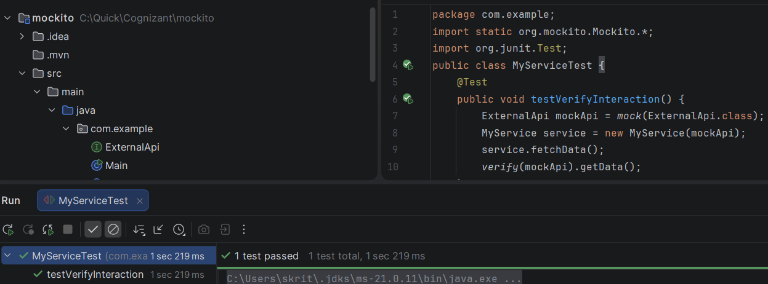

LOGGING USING SLF4J

EXERCISE 1: LOGGING ERROR MESSAGES AND WARNING LEVELS

Task: Write a Java application that demonstrates logging error messages and warning levels using SLF4J.
Step-by-Step Solution:

CODE:
package com.example;
import org.slf4j.Logger;
import org.slf4j.LoggerFactory;
public class LoggingDemo {
// Create a logger for this class
private static final Logger logger = LoggerFactory.getLogger(LoggingDemo.class);
public static void main(String[] args) {
// Log a warning message
logger.warn("This is a warning message.");
// Log an error message
logger.error("This is an error message.");
}
}

OUTPUT:
